TROES Corp.
PRODUCT SPEC SHEET

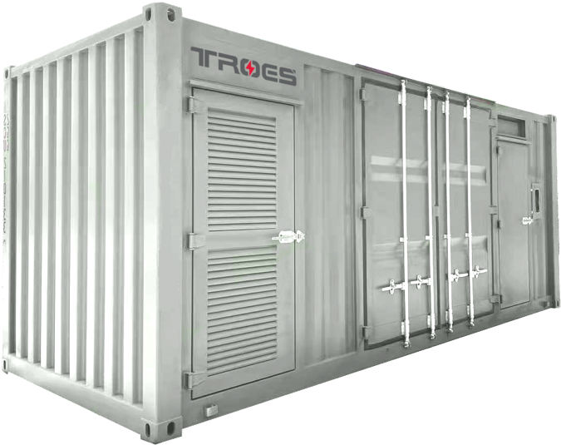

Battery
Energy
Storage
System (BESS)
HEADQUARTERS
401 Bentley Street, Unit 3
Markham, ON, Canada L3R 9T2

SALES INFO
+1-888-998-7637
info@troescorp.com
CONTACT INFO
support@troescorp.com
www.troescorp.com
Picture shown is for illustration purposes only.
Actual product may vary due to product or design enhancement.
- Modular Off-the-Shelf Approach: Scalable from 73kWh-10MWh+, with over 600 power output designs
- IoT & Cloud-Based Operation: Remote operation and prevention system reduces troubleshooting
- Dynamic Rate Support: Charge/Discharge rate from 30 minutes to 10+ hours
- Patented Intellectual Property: Bidirectional AC/DC PSC with on, off, or on & off grid connection system within a flexible enclosure
- Extended Operational Life: Retention of system’s usable capacity after 10+ years with ability to augment the system
- Leading Sustainability: Offerings include a fire suppression system solution emits low/zero emissions
Features and Benefits
TROES, established in 2018, is a Canadian advanced Battery Energy Storage Systems (BESS) provider. TROES specializes in developing, designing, manufacturing, and delivering smart, modular, cloud-managed energy storage systems using proprietary technology.

TROES sets itself apart from other energy storage providers by enabling mid-size projects with a safer, smarter, more adaptable and more economic turn-key solution.
Overview
Product Specifications¹

Model | TC--

Mechanical Specifications²
Electrical Specifications

Enclosure | NEMA 3R equivalent  (Outdoor Container)
Dimensions³  (L x W x H) | 6058 x 2438 x 2591mm
PCS Dimensions  (L x W x H) | x x mm
Number of Enclosures | # for Battery  +  # for PCS
Operating Temperature | -20^{O}C to 45^{O}C
System Weight | kg
HVAC | Optional
Fire Suppression System
Advanced Features (Optional) | Ultra-low temperature;  Low-cabinet design; Off-Gas detector etc;

Battery Technology | Lithium-ion / LFP
Battery Efficiency | %
Max C-Rate (charge/discharge) | C / C
DC Rated Current | A
DC Voltage | V
DC Voltage Operation Range | V – V
Installed Capacity | kWh
Usable Capacity | kWh
Rated AC Power | kW
Auxiliary AC Voltage | V, Phase
AC Rated Current | A
Nominal AC Frequency | 50 / 60Hz (configurable)
Protection
Communications

Integrated Microgrid Control Function | MiControlTM；  Other functions
Network | TCP/MODBUS/RS485
Safety & Grid Interface Certifications | UL1741, UL1973, UN38.3
- Rack Level Lockable Disconnect
- Lightning Protection
- Over-charge/Over-discharge Protection
- Over-temperature Protection
- External Accessible E-stop
- External Accessible Fire Control Panel
- Islanding Capability

1. In the interests of continual product improvement, specifications are subject to change without notice. Please contact us for the latest specifications.

2. Actual grid input requirement will depend on factors such as (but not limited to):
(i) actual equipment electrical requirements. (ii) utilization/duty cycle. (iii) daily duration of availability of input power supply.
(iv) state-of-health and age of the BESS. (v) duration of daily construction site operations.

3. An additional 0.9m clearance on all sides of the battery energy storage system should be provided for maintenance access.
HEADQUARTERS
401 Bentley Street, Unit 3
Markham, ON, Canada L3R 9T2

SALES INFO
+1-888-998-7637
info@troescorp.com
CONTACT INFO
support@troescorp.com
www.troescorp.com

